Context API

<https://www.udemy.com/course/the-complete-react-bootcamp-2020-w-react-hooks-firebase/learn/lecture/20588752#overview>

There is context API in react.

It introduces the concept of provider and consumer.

**Provider is a component** that provides all its children with some value or context.

**Consumer is a component** that consumes the context and gets the value using context API.

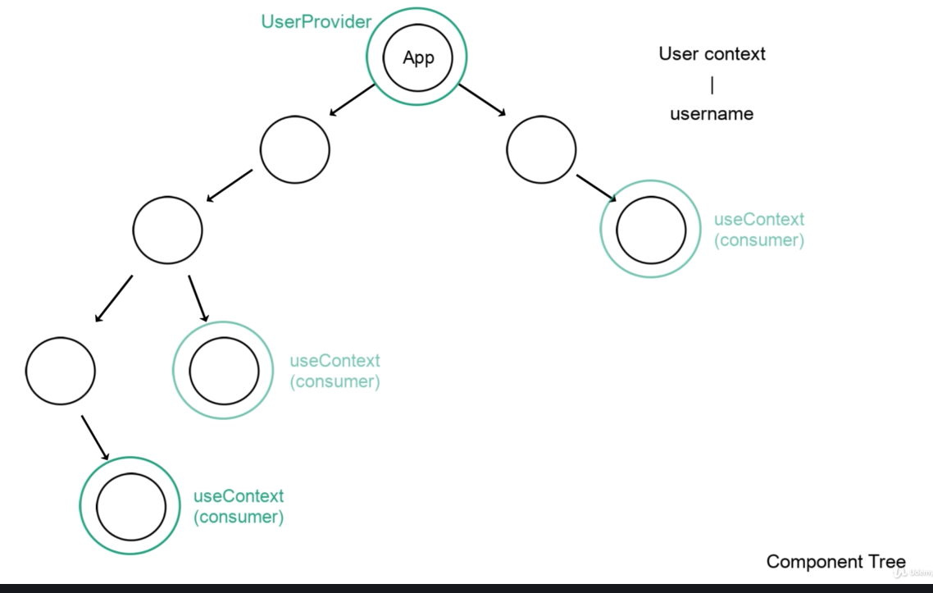

Prop Drilling – no good 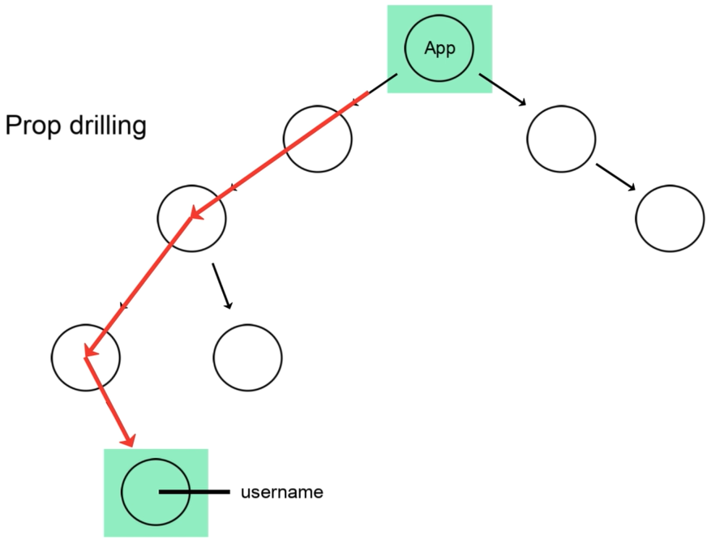Solution Context API 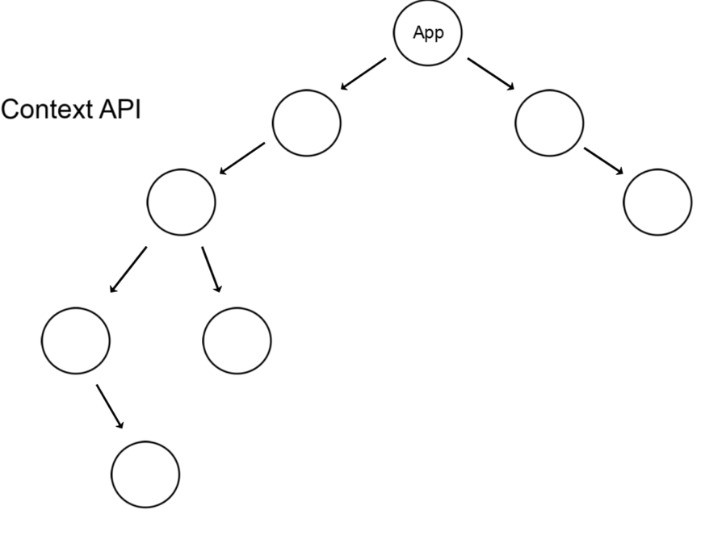

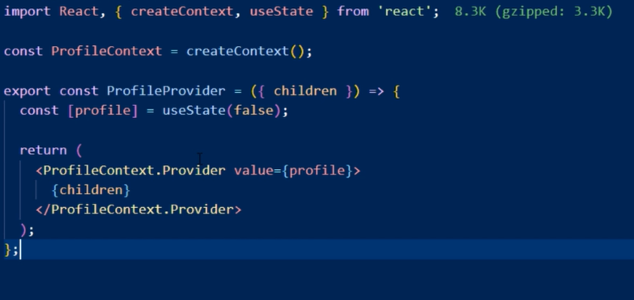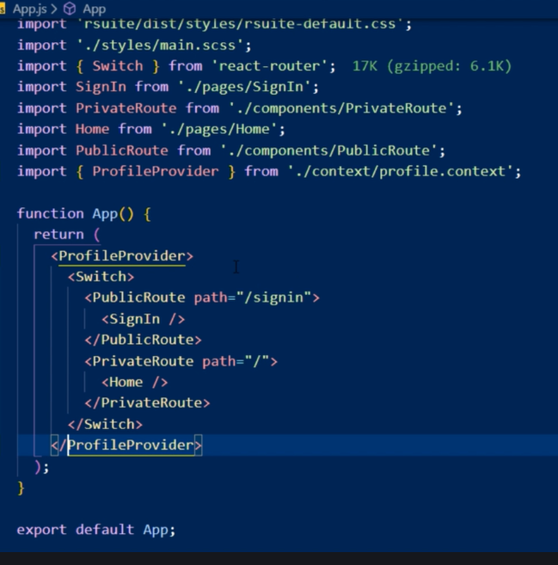

<https://www.udemy.com/course/the-complete-react-bootcamp-2020-w-react-hooks-firebase/learn/lecture/20590006#overview>

